Title here in Times new roman 18 (bold)
A. Presenting Authorª, B. Author^{b}, (Times new roman 12)

ªLaboratory affiliation 1 (Times new roman 12, italics)
^{b}Laboratory affiliation b

presenting.author@e-mail.com

Insert text here in times new roman 12 with references^{[1,2]} Please do not change page layout.
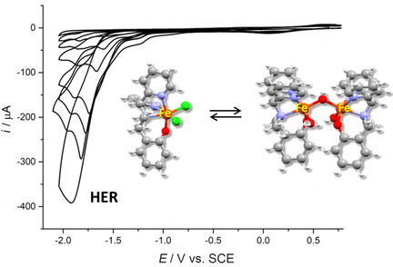
Figure 1. Still in times new roman 12.

We have utilized elemental analysis, Solid State ¹³C CP-MAS NMR, ICP, XRD and TEM, to fully define molecular features of the heterogeneous support order to evaluate its influence on the stability and durability of the catalytic system in cross-coupling reactions and in different reaction media. Catalyst leaching, recoverability and recyclability have been also investigated in details. In this communication, the most relevant feature of these research and the results obatined will be illustrated.

Please place references at the very bottom of the page by inserting empty lines.

[1] reference 1 ACS format, times new roman 10. Mika, L. T.; Csefalvay, E.; Nemeth, A. Chem. Rev., 2018, 118, 505–613.

